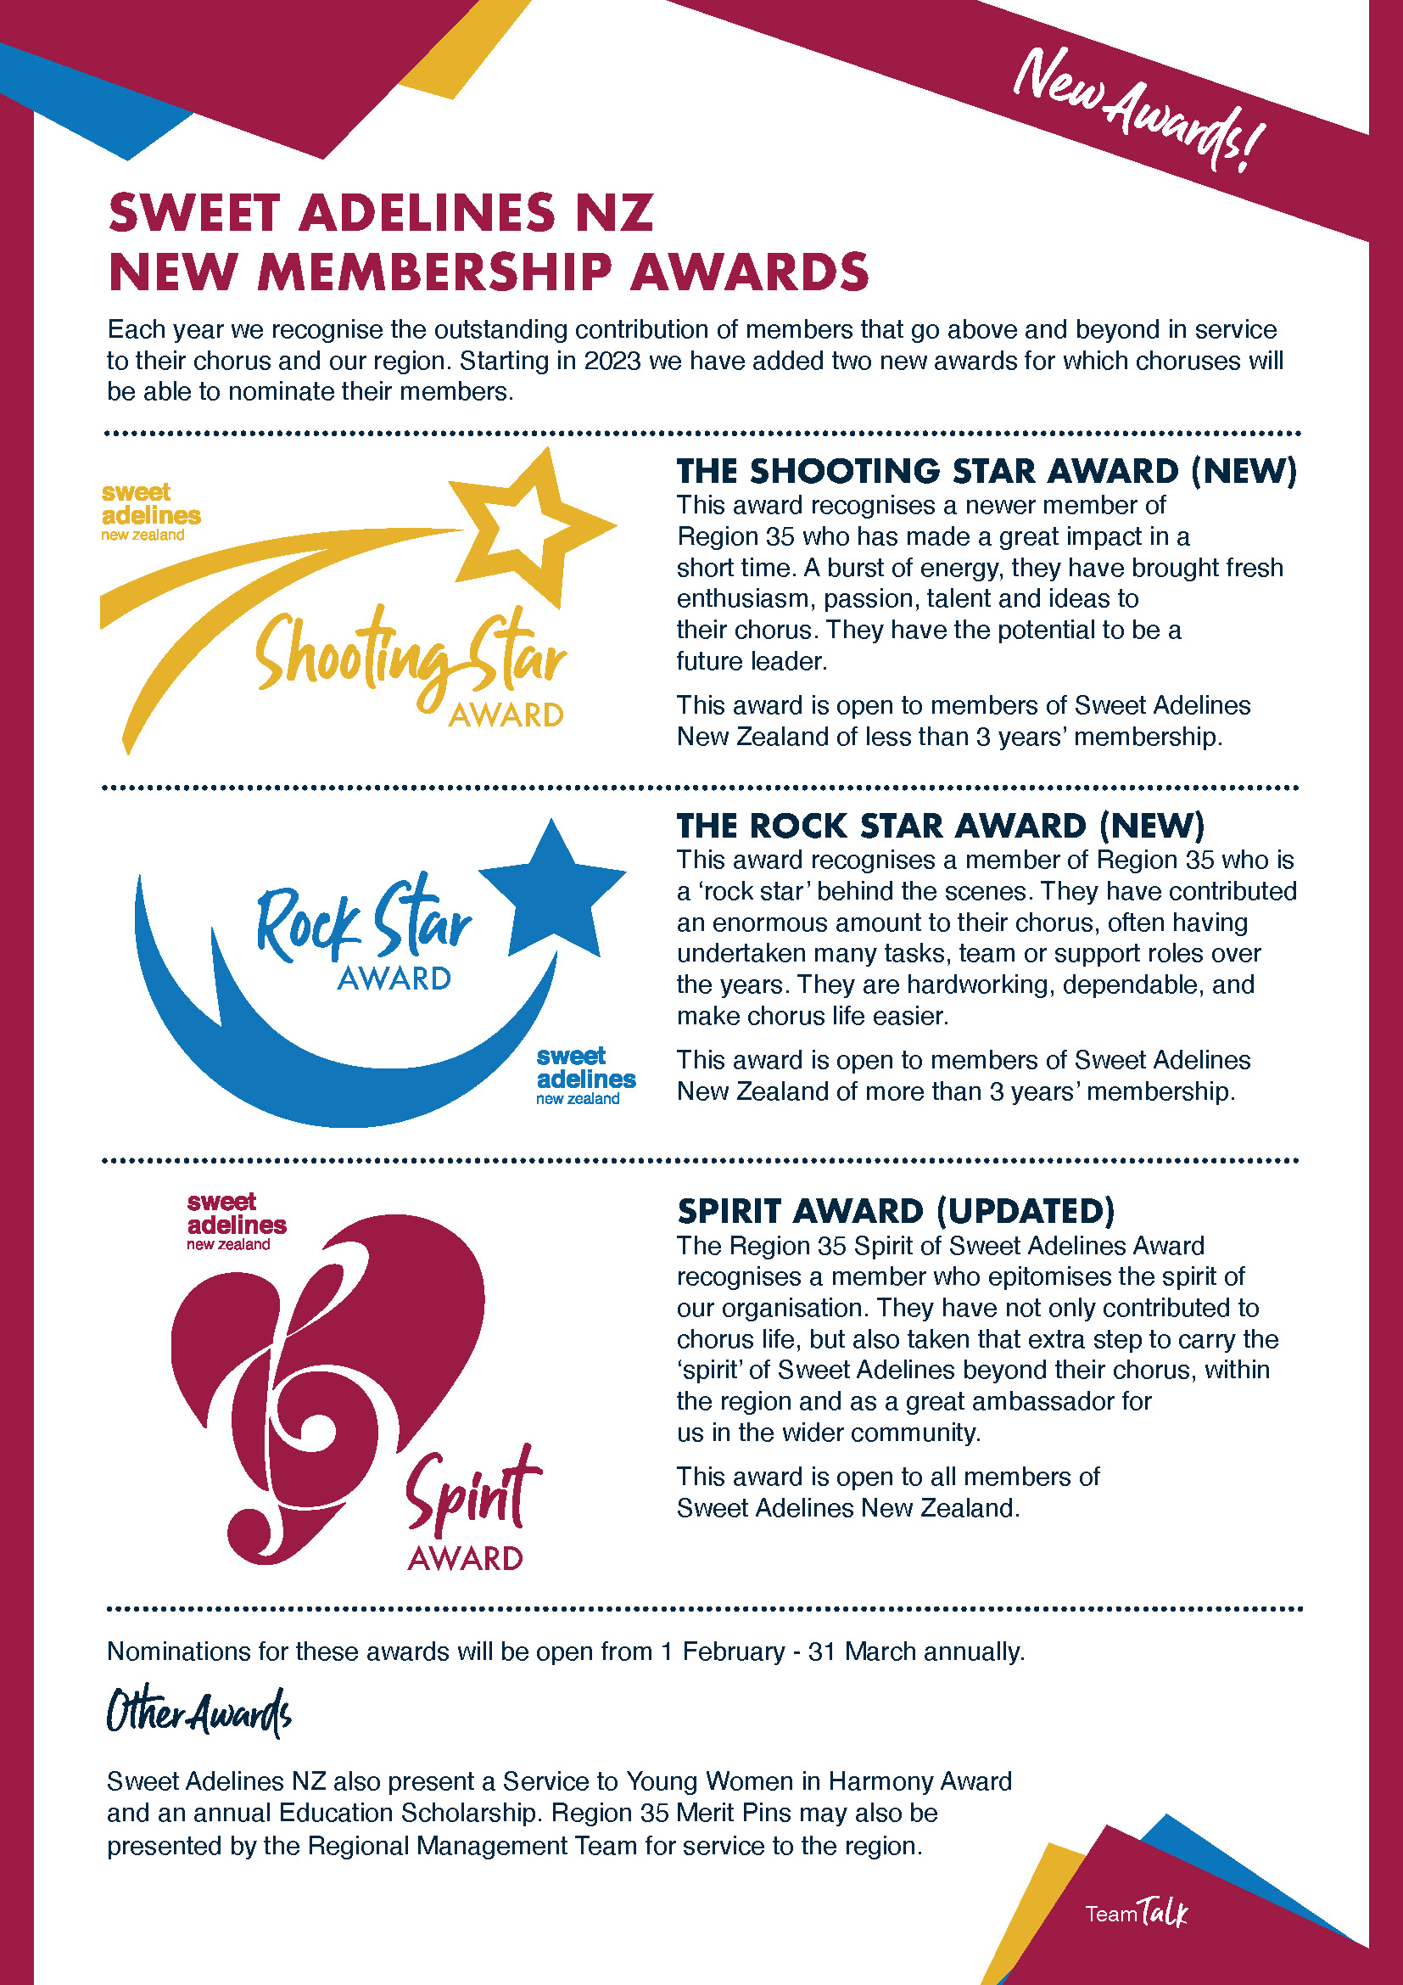

**Region 35 Membership Awards**

**Nomination Form 2023**

Select the Award from the following:

|  |  |  |  |  |  |
| --- | --- | --- | --- | --- | --- |
| Shooting Star Award |  | Rock Star Award |  | Spirit Award |  |

|  |  |
| --- | --- |
| Member Name: |  |
| Current Chorus |  |
| Years of membership |  |
| Positions Held |  |
|  |
|  |
|  |
|  |
| Nominated by |  |
| Chorus |  |
| Citation: Describe why this person should be nominated for the selected award. Please note that this information may be read out to the audience and/or published on SANZ website, social media and Addaline Magazine. (300 word maximum)  Please type this supporting information on the following sheet. | |

**Nominations including a photo of the nominee must be received by Wednesday 12 April 2023.**

Email to: membership@sweetadelines.co.nz

or post to: Miriam Spragg, 14 Richard Seddon Drive, Northwood, Christchurch 8051

**Membership Award Citation**

Nominee Name:

Supporting information for nomination:   
*(300 word maximum). Please note that this information may be read out to the audience at convention and/or published.*