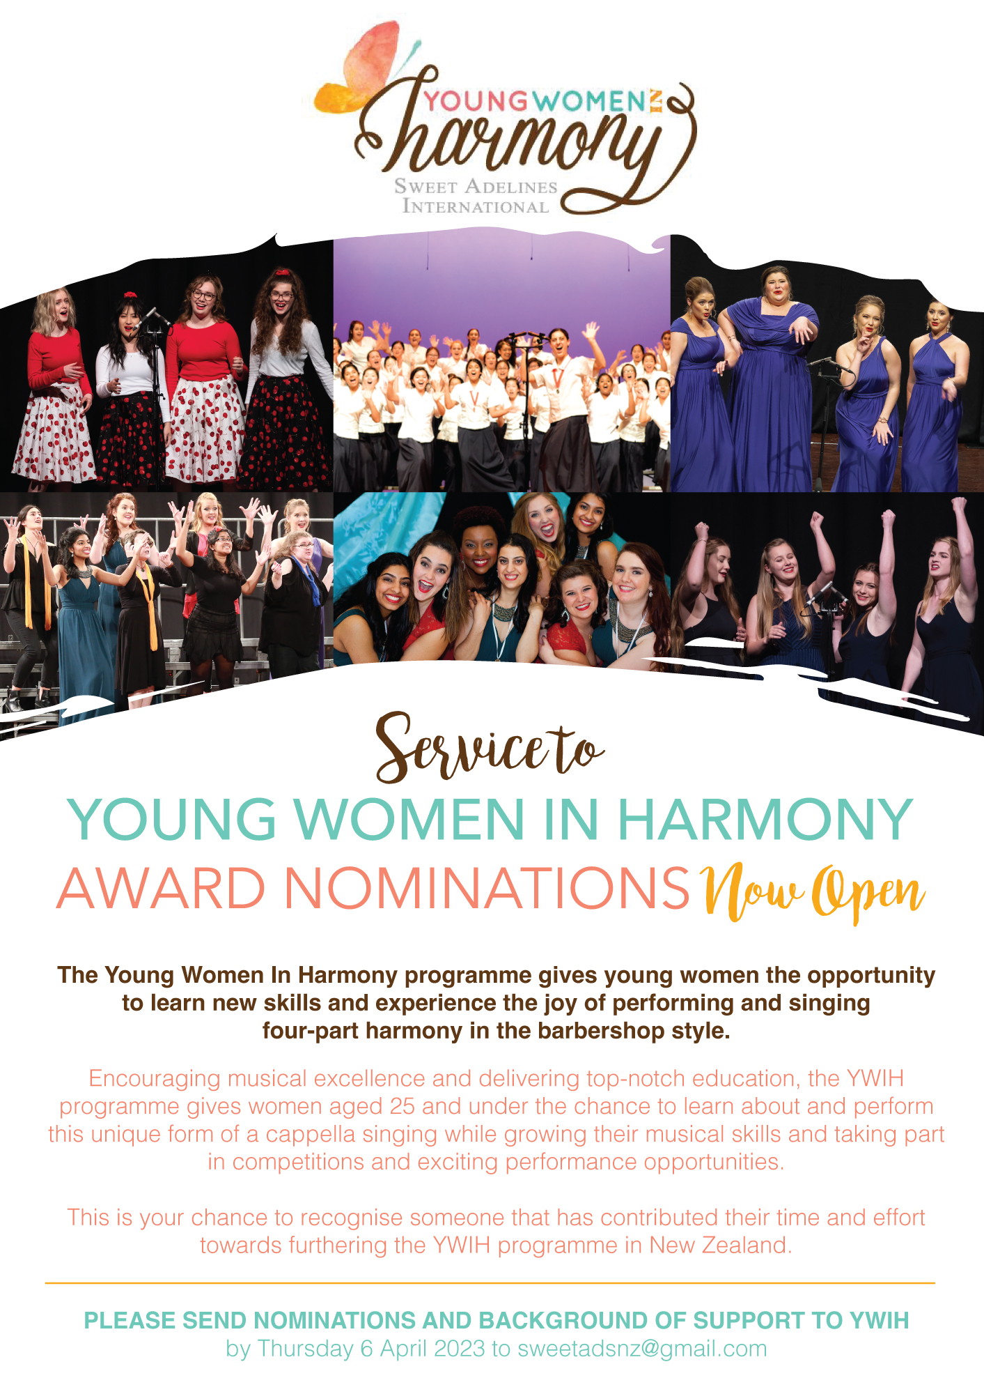

Service to Young Women in Harmony Award Nomination Form

Nominator

Chorus

Email
Phone
Nominee
Chorus
(if applicable)
Describe why this person should be nominated for this award. Please note that this information may be read out to the audience: (500 word maximum)

Send completed nomination form to education@sweetadelines.co.nz
before 6 April 2023

