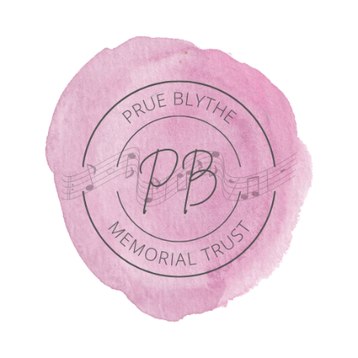

**PRUE BLYTHE MEMORIAL TRUST**

FUNDING APPLICATION FORM

|  |  |
| --- | --- |
| NAME |  |
| ADDRESS |  |
| EMAIL |  |
| PHONE |  |
| SCHOOL |  |
| QUARTET/CHORUS |  |

In order to be considered for funding from the Prue Blythe Memorial Trust you should align with the following guidelines:

* You and/or your quartet/chorus must be comprised of young women.
* You and/or your quartet/chorus must sing four-part harmony.
* You and/or your quartet/chorus must be based in Aotearoa New Zealand
* The use of funds for assisting secondary schools in the formation of a quartet or chorus
* The use of funds to create a musical competition in four-part harmony for young women in secondary schools.
* The use of funds to enable young women, still at secondary school, to attend international competitions for four-part harmony.
* Any other charitable purpose to support young women singing four-part harmony, agreed at the discretion of Trustees.

Tell us about the purpose of your request and how the funds are planned to be used.

|  |
| --- |
| E.g., Event details (Name, venue, date, expected participants, expected audience attendance)  Why you need funding in order to attend/participate  How attendance will benefit you and your quartet or chorus  How attendance will benefit your secondary school four-part harmony music program |

Have you applied for other Sweet Adelines New Zealand funding for the same purpose this this application? Y / N

Have you received funding from the PBMT in the past? Y / N

If yes, please provide details (date, amount, event etc).

Please attach any supporting documentation for application

* Event promotional material
* Successes in previous events
* Funds already received from other organisations to support the event for the same purpose as this application
* Quote/s for items requested
* A budget for the event the funds are being applied for (Admission fees, travel expenses etc)

Terms & Conditions:

In the case where the event is cancelled any funds received must be returned within one month.

If the application is successful, the applicant must complete an accountability report to the trust within three months of the event to show how funds received were applied.

If your application is successful, we will contact you and request bank account details.

Signed: *Digital signature accepted*

_______________________________________________________________

Name:

________________________________________________________________

Date:

______/_______/________

Please send your completed form to PBMT Chair Shelley Bascand

Shelley.bascand@gmail.com